Assignment 4

**NAME**: Eniola Osabiya

Answer

**Screenshot**:

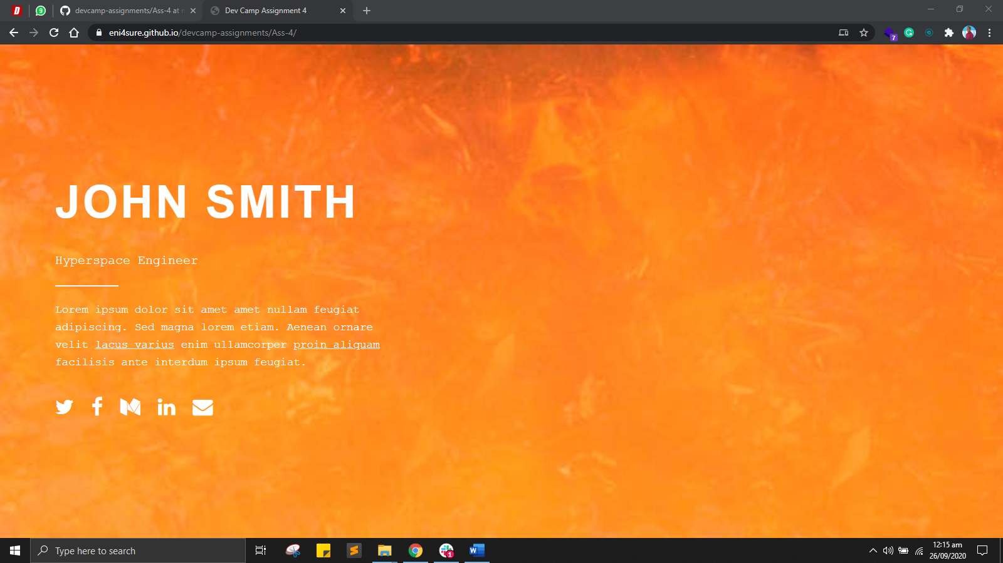  
  
**Live url hosted**:  
<https://eni4sure.github.io/devcamp-assignments/Ass-4/>  
  
**Source code**:

<https://github.com/eni4sure/devcamp-assignments/tree/master/Ass-4>